**WHY DO MY LEGS HURT???**

Typically, there are four periods of time at which athletes can be susceptible to injuries:

* During the initial phases of training (within the 1st month)
* Upon returning to sport after an injury (coming back too early, or too aggressive)
* When the quantity of running, suddenly, is increased (distance)
* When the quality of running, suddenly, is increased (speed)

Most running injuries are caused by recurring factors that athletes can often prevent or avoid themselves:

* **Training Errors:** can be the most common source of injury, particularly lack of adequate stretching, rapid changes in mileage, an increase in hill training, nutrition, and insufficient rest between training sessions.
* **Improper Running Shoes:** shoes should be running/training specific shoes that will accommodate your particular foot anatomy:
  + Proper shoes with good arch supports; should fit well and be comfortable.
  + **Track your shoes mileage/usage:** when a shoe’s mileage is reaching 300-350 miles, or have already been used for at least one season, then they need to be replaced due to breakdown of the shoe.
  + Orthotic shoe inserts (commercial, off-the-shelf, or custom-made) can be helpful for people with flat feet (pes planus), high-arched feet (pes cavus), ankle weakness/instability, or foot pain. **\*\*\*Orthotics can help with foot/ankle pain, but should not be the only approach taken in an attempt to relieve pain\*\*\***
  + Avoid running in “street” shoes, open-toed shoes, or someone else’s shoes.
  + Use your running/training shoes for **ONLY** running/training.
* **Surface:** if possible, run on surfaces which are flat, smooth, and reasonably soft. Try to avoid concrete, or rough road surfaces. Hills should be avoided, at first, due to increased stress placed on the lower extremities. Try to avoid multiple changing of surfaces during a run.
* **Nutrition/Hydration:**
  + Macronutrient breakdown for a balanced diet should represent something such as this: 50-60% Carbohydrates, 20-30% Protein, 20% Fats
  + Foods **NOT** to eat: fatty foods (slow stomach emptying), extremely salty foods (bloated feeling), and caffeinated/carbonated drinks (can cause intestinal problems, muscle tremors, headaches, nausea)
  + Pre-exercise hydration should consist of approximately 500-600mL (17-20 fl oz) of water 2-3 hours before exercise, and approximately 200-300mL (7-10 fl oz) of water 10-20 minutes before exercise.

What to do if injury is suspected:

* Stop running/playing, or modify your activity (remove what is causing pain)
* Report injury to your coach/athletic trainer
* Try to stay active as possible while modifying your activity
* If pain persists for more than 3 days then notify your athletic trainer. You may need to see a physician
* Be patient, these injuries take time to heal
* **See back side for stretches/exercises that you can try to help your condition**

**Diaphragmatic (Belly) Breathing**

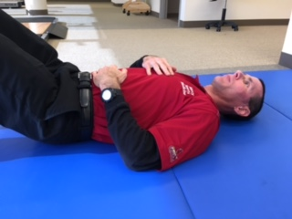 Lie on your back with your knees bent and feet on the bed/floor**.** Place one hand on your stomach and one hand on your chest.

Breathe in and out through your nose with your jaw relaxed and tongue on the roof of your mouth**.** Try to breathe as quietly as possible**.**

As you inhale, your belly and lower ribcage should expand, and as you exhale your belly should compress. The hand on your chest should stay as still as possible. Complete this exercise for 2-3 minutes.

**Intrinsic Foot Muscle**

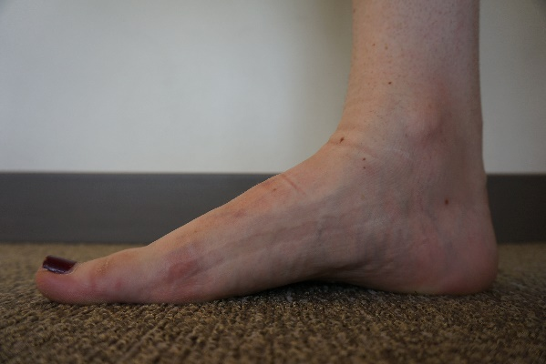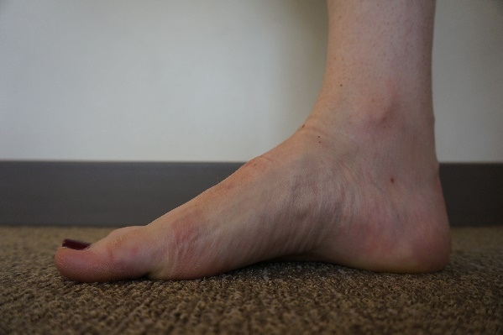

**Foot Doming (above):** bring big toe back toward your heel, creating an “arch” in your foot

**Lacrosse Ball Bottom of Foot**

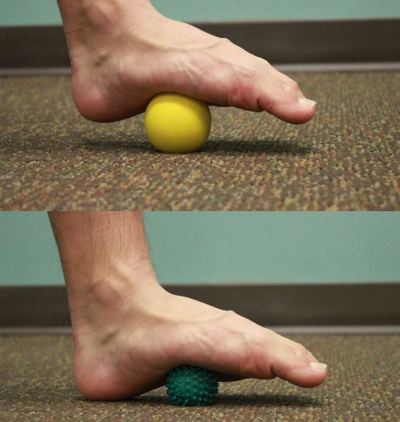 Place ball on the floor and your foot on top; move foot up/down (hit sore spots)

**Foam Rolling:** a self-myofascial release technique that is proven to improve range of motion and flexibility

